**INVENTORY MANAGEMENT SYSTEM**

**An internship report submitted in partial fulfillment of the requirements for the award of degree of**

## BACHELOR OF TECHNOLOGY

**in**

## COMPUTER SCIENCE AND ENGINEERING

## Submitted by:

**M. GAYATRI**

**(21MH1A05A9)**



## Department of Computer Science and Engineering

## (Accredited by NBA)

**ADITYA COLLEGE OF ENGINEERING**

**Approved by AICTE, permanently affiliated to JNTUK & Accredited by NAAC**

**Recognized by UGC under the sections 2(f) and 12(B) of the UGC act 1956**

**Aditya Nagar, ADB Road – Surampalem 533437, E.G. Dist., A.P.,**

**2023 – 2024**

**ADITYA COLLEGE OF ENGINEERING**

**Approved by AICTE, Permanently Affiliated to JNTUK & Accredited by NAAC**

**Recognized by UGC under the sections 2(f) and 12(B) of the UGC act 1956**

**Aditya Nagar, ADB Road – Surampalem – 533437, E.G. Dist., A.P.,**

**Department Of Computer Science and Engineering**

## (Accredited by NBA)



# CERTIFICATE

This is to certify that **MAMIDIPALLI. DHARANI GAYATRI** Reg. No. **21MH1A05A9** has completed his Internship in **Technical Hub Pvt. Ltd.,**on **Problem Solving and JAVA** as a part of partial fulfillment of the requirement for the Degree of **Bachelor of Technology** in the Department of **Computer Science and Engineering** for the academic year 2023-2024.

**Internship Coordinator Head of the Department**

Mrs. P.N. S Lakshmi, M. Tech Dr. G.S.N. MURTHY, Ph. D

Assistant Professor Professor & HOD

Department of CSE Department of CSE

**External Examiner**

# DECLARATION

I **MAMIDIPALLI. DHARANI GAYATRI** a student of **Bachelor of Technology** Program, Reg. No. **21MH1A05A9** of the Department of **Computer Science and Engineering, Aditya College of Engineering** do hereby declare that I have completed the mandatory internship from 22**-05-2023** to 17**-06-2023** in **Technical Hub Pvt. Ltd.,**on **Problem solving And JAVA** under the Faculty Guideship of **Mrs. P.N.S Lakshmi**, Department of **Computer Science and Engineering, Aditya College of Engineering.**

**By**

**M. GAYATRI**

**(21MH1A05A9)**

# Internship Completion Certificates

# 

# 

**ACKNOWLEDGEMENT**

First, I would like to thank the Directors of Technical Hub Pvt. Ltd., Surampalem for giving me the opportunity to do an internship within your organizations. I would like to thank our internship mentors

**Mr. Ashok Maranala, Mr. Srinu Marni** who have guided us a lot and encouraged us in every step of the internship project work. I also would like all the people that worked along with me in Technical Hub Pvt. Ltd.,

It is with immense pleasure that we would like to express our indebted gratitude to our internship coordinator **Mrs. P.N. S Lakshmi, Assistant Professor,** who has guided us a lot and encouraged us in every step of the intern project work, **her** valuable moral support and guidance throughout the Intern project helped us to a greater extent.

Our deepest thanks to **Dr. G.S.N. MURTHY, Professor & Head of the Department** for inspiring us all the way and for arranging all the facilities and resources needed for our Intern.

We wish to thank **Dr. PULLELA S V V S R KUMAR, Professor** in CSE and Dean (Academics) for his support and suggestions during our internship work.

We owe our sincere gratitude to **Dr. A RAMESH, Principal** for providing a great support and for giving us the opportunity of doing the Internship.

We are thankful to our **College Management** for providing all the facilities in time to us for completion of our internship.

Not to forget, **Faculty, Lab Technicians, non-teaching staff and our friends** who have directly or indirectly helped and supported us in completing our internship in time.



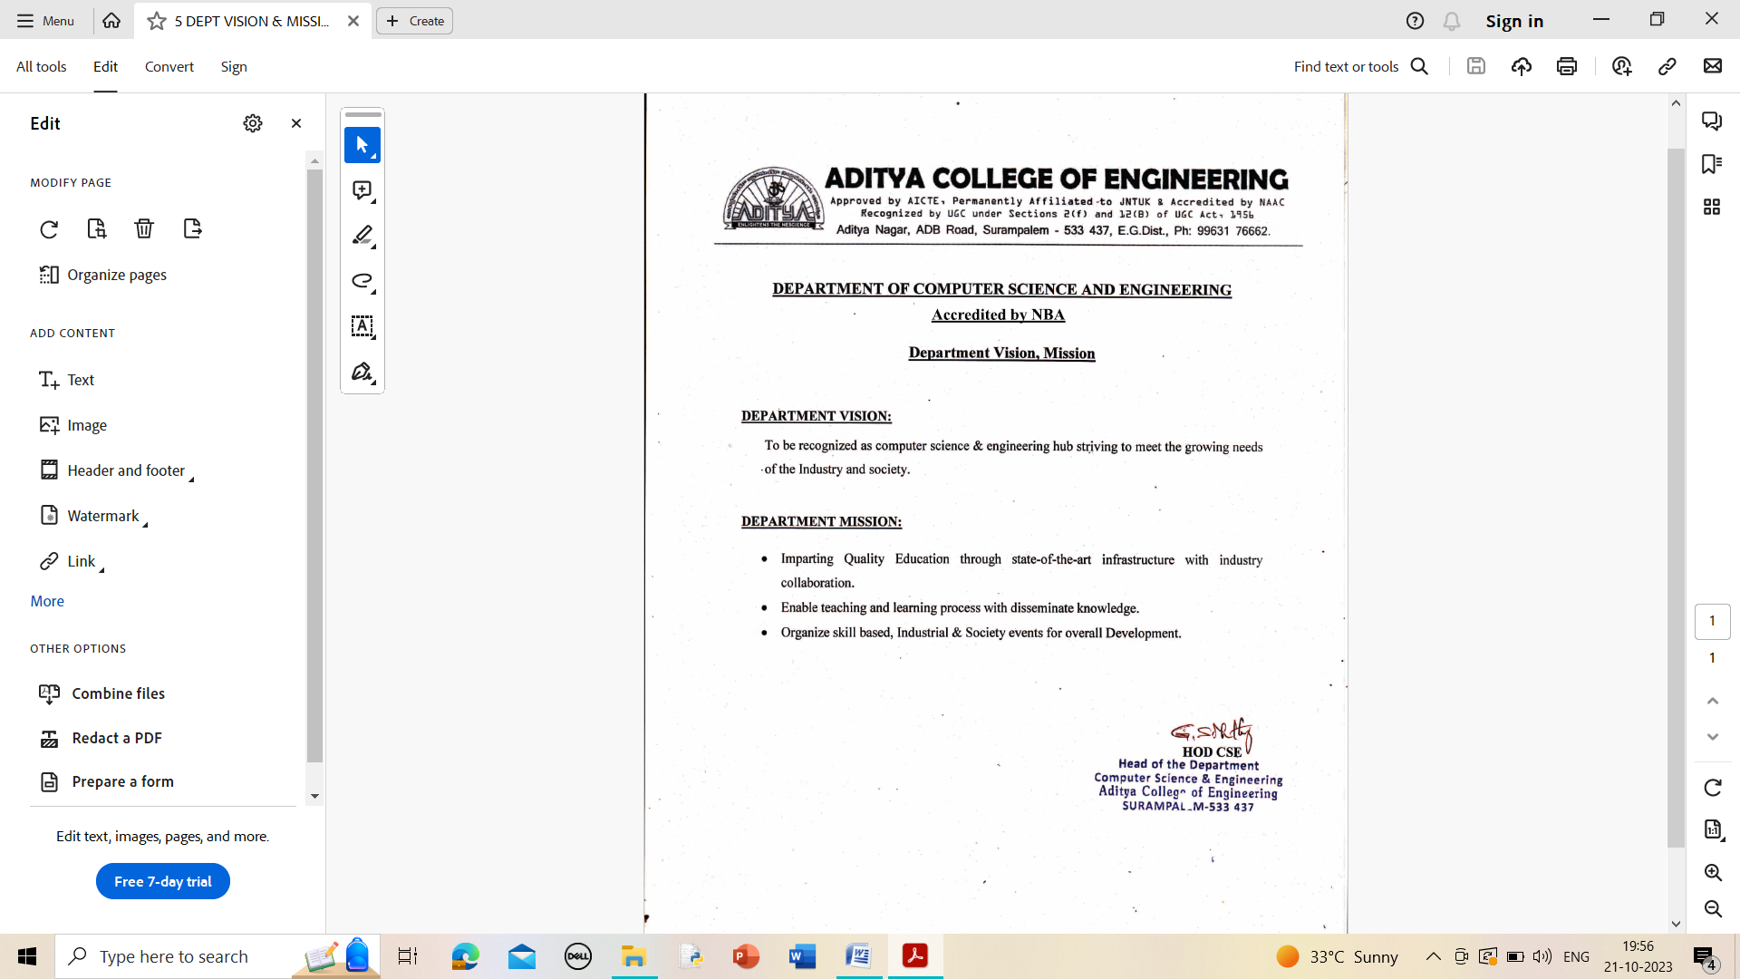

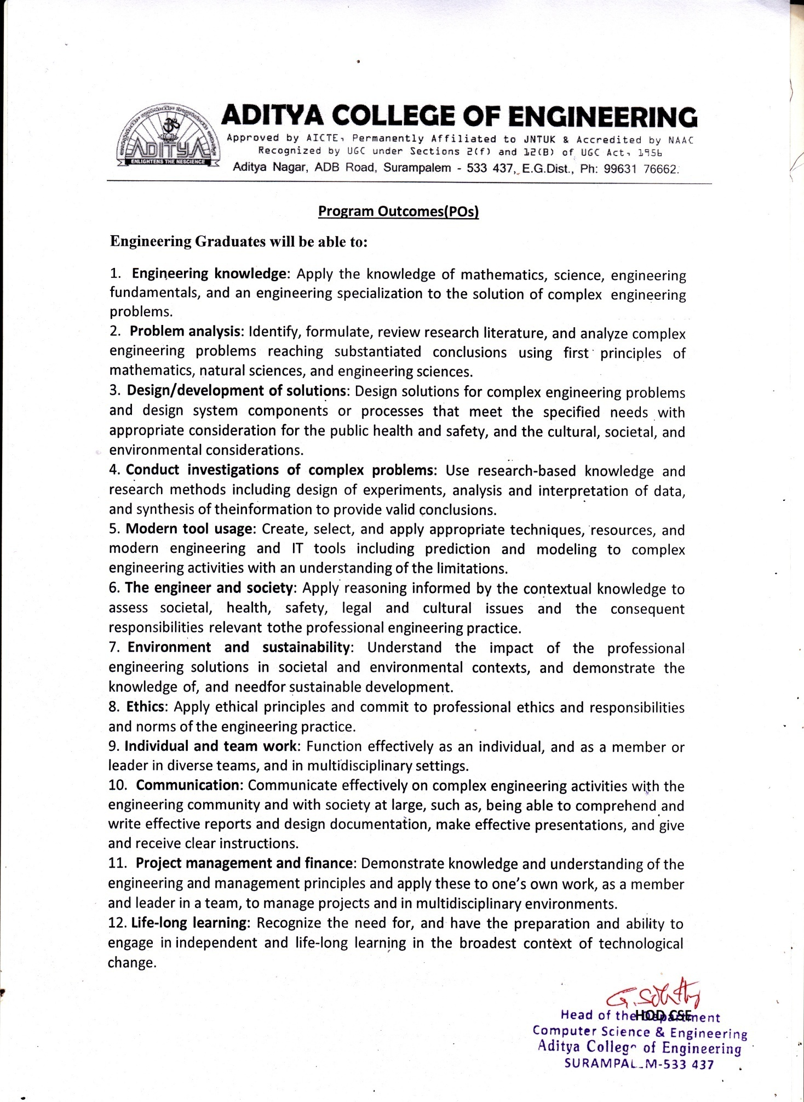

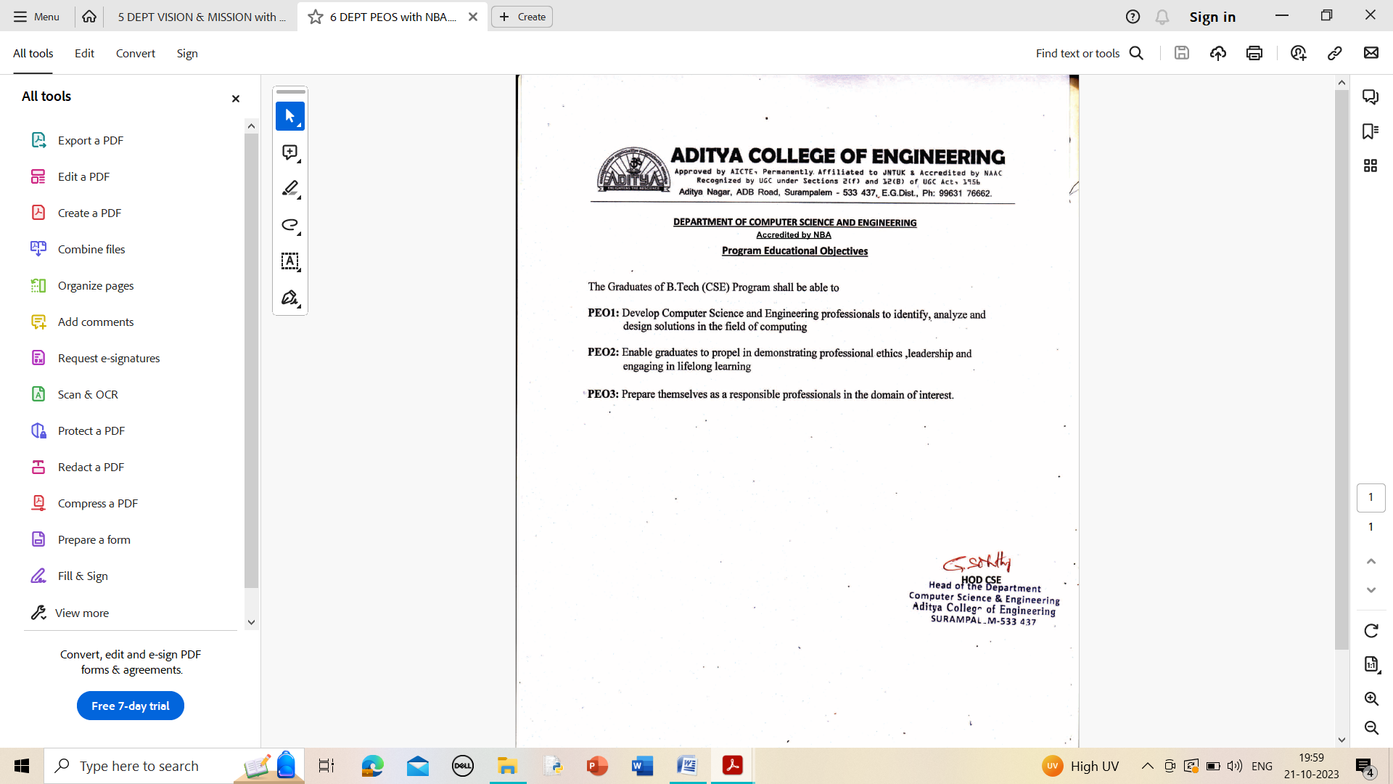



**INDEX**

|  |  |  |
| --- | --- | --- |
| **S. NO** | **TOPIC** | **PAGE NO** |
| 1 | Abstract | 1 |
| 2 | Introduction | 2 |
| 3 | Learning Objectives/Internship Objectives | 3 |
| 4 | Day To Day Overview of Internship Activities | 4-5 |
| 5 | Weekly Report | 6-7 |
| 6 | Executive Summary | 8 |
| 7 | About The Company | 9 |
| 8 | Opportunities | 10 |
| 9 | Training | 11 |
| 10 | Challenges Faced | 12 |
| 11 | About Project | 13-19 |
| 12 | Student Self Evaluation sheet | 20 |
| 13 | Photos & Video Links | 21-22 |

# 1.ABSTRACT

During these 4 weeks of internship there are totally 18 Offline sessions, 18 practical sessions and total of 12 application development sessions are held. Duration of Offline and Practical sessions is 3 hrs per each and each application development session of duration 6 hrs.

In Offline sessions our mentors gave training on the given topics:

* Java-OOP’s Concepts
* Exception Handling and Multi-Threading
* GUL tools (Swing, AWT).
* JDBC connectivity.
* MySQL Workbench.

There is a badge to be completed for completion of internship that is: Hacker Rank Java Programming. At the end of the internship, we have been divided into groups and each group has been assigned with Java projects in real-time applications scenarios.

**Project Abstract:**

The Inventory management system is a comprehensive solution designed to enhance the efficiency of Inventory store products searching. The Inventory management system is a GUI-based Java application for managing a product inventory using JDBC database connectivity. It is designed to help businesses efficiently manage their product inventory. This system provides a set of essential features and allows the users to view, add and update product details stored in MYSQL database. And it maintains a list of products with details including product ID, name, quantity and cost. It provides a user-friendly interface for interacting with the inventory and ensures data integrity.

# 2. INTRODUCTION

During my internship in Java, I delved into the foundational aspects of programming, with a primary focus on Object-Oriented Programming (OOP), Exception Handling, GUI Tools (Swing And AWT) and JDBC Connectivity. This immersive experience has equipped me with the essential skills and knowledge needed to excel in Java development.

I gained a deep understanding of OOP principles, which form the backbone of Java development. This involved creating and managing classes, objects, and inheritance, as well as encapsulation, polymorphism, and abstraction. These concepts have not only allowed me to write more organized and modular code but also to design robust software systems.

Exception Handling became a crucial part of my learning journey, enabling me to handle unforeseen errors and issues gracefully. I learned to identify, catch, and manage exceptions effectively, ensuring that my Java applications run smoothly even when unexpected situations arise.

Swing is a Java GUI library that offers a wide range of customizable and platform-independent graphical user interface components. It's built on AWT and provides consistent, modern, and attractive GUI elements for desktop applications.

AWT, the Abstract Window Toolkit, is the original Java GUI library that provides basic GUI components. It relies on native platform rendering, which can lead to platform-specific appearances. AWT components are part of the Java core libraries and offer simplicity but may lack modern features.

Throughout my internship, I embraced a hands-on approach, applying these concepts to real-world Java projects and assignments. I look forward to leveraging the skills I've acquired to contribute effectively to Java development, problem-solving, and software engineering during my internship and beyond.

# 3.LEARNING OBJECTIVES/INTERNSHIP OBJECTIVES

* Internships are generally thought of to be reserved for college students looking to gain experience in a particular field. However, a wide array of people can benefit from Training Internships in order to receive real world experience and develop their skills.
* An objective for this position should emphasize the skills you already possess in the area and your interest in learning more
* Internships are utilized in a number of different career fields, including architecture, engineering, healthcare, economics, advertising and many more.
* Some internships are used to allow individuals to perform scientific research while others are specifically designed to allow people to gain first-hand experience working.
* Utilizing internships is a great way to build your resume and develop skills that can be emphasized in your resume for future jobs. When you are applying for a Training Internship, make sure to highlight any special skills or talents that can make you stand apart from the rest of the applicants so that you have an improved chance of landing the position.

# 4. DAY TO DAY OVERVIEW OF INTERNSHIP ACTIVITIES

|  |  |  |
| --- | --- | --- |
| **DATE** | **TOPIC** | **HOURS** |
| 22-05-2023 | Offline Session 1 – Basic of Java OOP’s  Offline Session 2 – Self-Paced Learning | 6 hrs. |
| 23-05-2023 | Offline Session 1 – Class and Objects  Offline Session 2 – Self-Paced Learning | 6 hrs. |
| 24-05-2023 | Offline Session 1 – Method Passing  Offline Session 2 – Self-Paced Learning | 6 hrs. |
| 25-05-2023 | Offline Session 1 – Inheritance  Offline Session 2 – Self-Paced Learning | 6 hrs. |
| 26-05-2023 | Offline Session 1 – Polymorphism  Offline Session 2 – Self-Paced Learning | 6 hrs. |
| 27-05-2023 | Offline Session 1– Abstraction & Interface.  Offline Session 2 – Self-Paced Learning | 6 hrs. |
| 29-05-2023 | Offline Session 1 – Exception Handling  Offline Session 2 – Self-Paced Learning | 6 hrs. |
| 30-05-2023 | Offline Session 1– User Defined Exception  Offline Session 2 – Self-Paced Learning | 6 hrs. |
| 31-05-2023 | Offline Session 1– Baisc on Threading  Offline Session 2 – Self-Paced Learning | 6 hrs. |
| 01-06-2023 | Offline Session 1 – Introduction to JDBC  Offline Session 2 – Self-Paced Learning | 6 hrs. |
| 02-06-2023 | Offline Session 1 – JDBC Drivers  Offline Session 2 – Self-Paced Learning | 6 hrs. |
| 03-06-2023 | Offline Session 1 – JDBC Connectivity  Offline Session 2 – Self-Paced Learning | 6 hrs. |
| 05-06-2023 | Offline Session 1–Introduction to GUI tools  Offline Session 2 – Self-Paced Learning | 6 hrs. |
| 06-06-2023 | Offline Session 1 – Java Swing  Offline Session 2 – Self-Paced Learning | 6 hrs. |
| 07-06-2023 | Offline Session 1 – Java AWT  Offline Session 2 – Self-Paced Learning | 6 hrs. |
| 08-06-2023 | Offline Session 1 – Java Packages  Offline Session 2 – Self-Paced Learning | 6 hrs. |
| 09-06-2023 | Offline Session 1 – User Defined Packages  Offline Session 2 – Self-Paced Learning | 6 hrs. |
| 10-06-2023 | Offline Session 1 – Java Class Paths  Offline Session 2 – Self-Paced Learning | 6 hrs. |
| 12-06-2023 | Assigning Groups & Projects Decisions | 6 hrs. |
| 13-06-2023 | Mentor Sessions for Project Development | 6 hrs. |
| 14-06-2023 | Developing the Project Interface | 6 hrs. |
| 15-06-2023 | Soft Skills Training & Career Fair Session | 6 hrs. |
| 16-06-2023 | Projects Validation & FAQ’s | 6 hrs. |
| 17-06-2023 | Final Examination &  Certificate Generation. | 6 hrs. |

**5.** **WEEKLY REPORT**

|  |  |
| --- | --- |
| **Boot camp** | **Table of Content** |
| **Week-1** | Java OOP’s.  Class and Objects.  Method Passing.  Inheritance.  Polymorphism.  Abstraction and Interference. |
| **Week-2** | Exception Handling.  User Defined Exceptions.  Introduction to Threads.  Introduction to JDBC.  JDBC Drivers.  JDBC Connectivity. |
| **Week-3** | Introduction to GUI Tools.  JAVA Swing.  JAVA AWT.  JAVA Packages.  User Defined Packages.  JAVA Class Paths. |
| **Last Week** | Project  Ask A Mentor Sessions  Submissions  Verification  Certificate Generation |

# EXECUTIVE SUMMARY

This report is about my 4 weeks internship program with Technical Hub Pvt. Ltd., (Surampalem). In this comprehensive report, I have discussed about every major aspect of the company which I observed and perceived during my internship program.

During my internship program, I have learned and mainly worked on Problem Solving And JAVA. All the details have been discussed in detail. All the policies and procedures of the company have been discussed in detail.

As per Technical Hub Pvt. Ltd., The purpose of the internship is to learn, by working in practical environment and to apply the knowledge acquired during the studies in real world scenario in order to tackle the problems using the knowledge and skill learned during the academic process.

# ABOUT THE COMPANY

Technical Hub Pvt. Ltd., provides the trainings which are certification aligned and associated with various vendors that are top in the industry. Members who are part of this program are given a constant practical example on various topics, thus keeping them abreast of their technological world. It is located in Surampalem, Andhra Pradesh. Founded by Babji Neelam, Technical Hub Pvt.Ltd., quickly grew into one of the largest companies in the Kakinada.

Today, Technical Hub Pvt. Ltd is one of the largest technology Educator in Kakinada.

**Mission**: Technical Hub Pvt.Ltd, the Student Success Platform Improving the knowledge base with rapidly evolving technological skills, the skill to communicate across discipline, the ability to lead team-centered projects, contextualized problem formulation and hand-on experience is the present demand of the global industry. To meet this demand, Aditya initiated t-Hub: a perfect launch pad to the job world. T-Hub trains students in various disciplines beyond technological labels.

**Vision**: We believe that the business of business is to improve the state of the world, and we work to make sure Technical Hub Pvt. Ltd is a platform for change through serving the interests of all our stakeholders — employees, customers, partners, communities and the environment.

# OPPORTUNITIES

During these 4 Weeks of the internship, I was given the opportunity to perform following role:

* + - **Intern:** Coordinating with the team members and team leads on a regular basis to keep a track of the activities like the Offline sessions held and about the work to be done.
    - I learned about how to connect data to database.
    - For that I have referred the GitHub repositories related to gain the complete knowledge on Connecting database.
    - Then I have gathered the requirements for connection of database.
    - They also provide us the opportunity to voluntarily interact in other projects as well.
    - They have given different tasks to develop different parts of the application.
    - I learned about OOPs Concepts, Exception Handing, GUI tools (Swing and AWT).
    - Also, they have finally conducted test to certify with the completion of internship.

# TRAINING

During these 4 weeks of internship there are totally 18 Offline sessions, 18 practical sessions and total of 12 application development sessions are held. Duration of Offline and Practical sessions is 3 hrs per each and each application development session of duration 6 hrs.

In Offline sessions our mentors gave training on the given topics:

* Java-OOP’s Concepts
* Exception Handling and Multi-Threading
* GUL tools (Swing, AWT)
* JDBC Connectivity.
* MySQL Workbench.

## Hacker Rank Java- Badge:

**I completed the below mentioned process and earned the java badge.**

1. I Solved Java coding challenges on the platform.

2. Made sure my code is correct and efficient.

3. Tested my code against provided test cases.

4. Submitted my solutions for evaluation.

5. As I solved more challenges, I earned points and badges.

6. To keep on practicing and solving more challenges to improve and earn points.

# 10. CHALLENGES FACED

* At the beginning of internship, I faced difficulty for understanding the applications and different tools.
* I faced difficulty in installing the packages.
* I faced difficulty in understanding the advanced topics on java oops.
* I faced difficulty in network issues.
* I faced difficulty in getting the hang of the language’s syntax.
* I faced difficulty while implementing Swings and AWT Tools.
* I faced difficulty in JDBC Connectivity and usage of JDBC drivers.
* I faced difficulty while handling the errors in exception handling syntax.

Even with these difficulties, I am able to complete the internship so that it will help me to secure a job in near future.

**11.ABOUT PROJECT**

**11.1** – **Project Introduction:**

* The Inventory Management System is a Java-based software designed to help businesses efficiently manage their product inventory. The Inventory management system offers a graphical user interface (GUI) to manage a product inventory using JDBC database connectivity. Leveraging Java's capabilities and JDBC for robust database integration, the system ensures reliable data storage and retrieval, while its secure login and authentication features protect sensitive information. The Inventory Manager Dashboard empowers with functionalities for selling Inventory products, updating stock, and viewing customer details, streamlining the overall Inventory management process.
* This comprehensive system caters to the unique needs of customers, fostering a user-friendly experience. Its ability to handle Inventory products, product sales, and bill generation adds a layer of efficiency to Inventory Stores. The project embodies a commitment to improving product services by providing a seamless and organized approach to inventory management, ultimately contributing to enhanced customer care and satisfaction.

**11.2** – **Project Requirements:**

Hardware:

**Processor:** Intel – I3.

**RAM:** 2 GB.

**Hard Disk:** 256 GB.

Software:

**OS:** Windows / MAC / Linux.

**JAVA:** JDK Version (16,17,20).

**Database:** MySQL Workbench.

**IDE:** NetBeans IDE

**11.3** – **Project Modules:**

* **Admin Authentication -** Essential for data protection, it requires valid login credentials for system access.
* **Inventory Management-** Tracks and updates information about the products, including stock levels, selling and cost prices.
* **Sales -** Handles the process of adding products to the cart for selling products of the customers.
* **Billing –** Handles the process of generating bills, and maintaining transaction history of the customers.

**11.4** – **Project Implementation (Sample Code):**

**HOME PAGE:**

package inventory;

import java.awt.*;

import java.awt.event.ActionEvent;

import java.awt.event.ActionListener;

import javax.swing.*;

public class Dashboard extends JFrame implements ActionListener {

JFrame f;

private String username = "";

JButton inventoryproduct, inventoryviewproduct, inventoryupdateproduct, inventorysellproduct, inventoryviewbill, inventoryexit;

public Dashboard(String tempUsername) {

f = new JFrame("Home Page");

f.setBackground(Color.BLACK);

f.setBounds(0, 0, 700, 500);

f.setLayout(null);

JLabel inventorydash = new JLabel("DASHBOARD");

inventorydash.setBounds(520, 80, 400, 60);

inventorydash.setFont(new Font("Times New Roman", Font.BOLD, 40));

inventorydash.setForeground(Color.BLUE);

f.add(inventorydash);

ImageIcon i1 = new ImageIcon(ClassLoader.getSystemResource("images/addProduct.png"));

Image i2 = i1.getImage().getScaledInstance(50, 60, Image.SCALE_DEFAULT);

inventoryproduct = new JButton("Add Product", new ImageIcon(i2));

inventoryproduct.setBounds(300, 200, 250, 60);

inventoryproduct.setFont(new Font("Times New Roman", Font.BOLD, 20));

inventoryproduct.setBorder(BorderFactory.createLineBorder(Color.black));

inventoryproduct.setFocusPainted(false);

inventoryproduct.addActionListener(this);

f.add(inventoryproduct);

ImageIcon i5 = new ImageIcon(ClassLoader.getSystemResource("images/updateUser.png"));

Image i6 = i5.getImage().getScaledInstance(50, 60, Image.SCALE_DEFAULT);

inventoryupdateproduct = new JButton("Update Product", new ImageIcon(i6));

inventoryupdateproduct.setBounds(300, 300, 250, 60);

inventoryupdateproduct.setFont(new Font("Times New Roman", Font.BOLD, 20));

inventoryupdateproduct.setBorder(BorderFactory.createLineBorder(Color.black));

inventoryupdateproduct.setFocusPainted(false);

inventoryupdateproduct.addActionListener(this);

f.add(inventoryupdateproduct);

ImageIcon i9 = new ImageIcon(ClassLoader.getSystemResource("images/viewUser.png"));

Image i10 = i9.getImage().getScaledInstance(50, 60, Image.SCALE_DEFAULT);

inventoryviewproduct = new JButton("View Product", new ImageIcon(i10));

inventoryviewproduct.setBounds(300, 400, 250, 60);

inventoryviewproduct.setFont(new Font("Times New Roman", Font.BOLD, 20));

inventoryviewproduct.setBorder(BorderFactory.createLineBorder(Color.black));

inventoryviewproduct.setFocusPainted(false);

inventoryviewproduct.addActionListener(this);

//login.addActionListener(this);

f.add(inventoryviewproduct);

ImageIcon i11 = new ImageIcon(ClassLoader.getSystemResource("images/sellProduct.png"));

Image i12 = i11.getImage().getScaledInstance(50, 60, Image.SCALE_DEFAULT);

inventorysellproduct = new JButton("Sell Product", new ImageIcon(i12));

inventorysellproduct.setBounds(700, 200, 250, 60);

inventorysellproduct.setFont(new Font("Times New Roman", Font.BOLD, 20));

inventorysellproduct.setBorder(BorderFactory.createLineBorder(Color.black));

inventorysellproduct.setFocusPainted(false);

inventorysellproduct.addActionListener(this);

f.add(inventorysellproduct);

ImageIcon i13 = new ImageIcon(ClassLoader.getSystemResource("images/viewBill.png"));

Image i14 = i13.getImage().getScaledInstance(50, 60, Image.SCALE_DEFAULT);

inventoryviewbill = new JButton("View Bill", new ImageIcon(i14));

inventoryviewbill.setBounds(700, 300, 250, 60);

inventoryviewbill.setFont(new Font("Times New Roman", Font.BOLD, 20));

inventoryviewbill.setBorder(BorderFactory.createLineBorder(Color.black));

inventoryviewbill.setFocusPainted(false);

inventoryviewbill.addActionListener(this);

//login.addActionListener(this);

f.add(inventoryviewbill);

ImageIcon i17 = new ImageIcon(ClassLoader.getSystemResource("images/exit.png"));

Image i18 = i17.getImage().getScaledInstance(50, 60, Image.SCALE_DEFAULT);

inventoryexit = new JButton("Exit", new ImageIcon(i18));

inventoryexit.setBounds(520, 500, 250, 60);

inventoryexit.setFont(new Font("Times New Roman", Font.BOLD, 20));

inventoryexit.setBorder(BorderFactory.createLineBorder(Color.black));

inventoryexit.setFocusPainted(false);

inventoryexit.addActionListener(this);

f.add(inventoryexit);

f.setVisible(true);//Setting the visibility of the Frame

f.setSize(1300, 768);

f.setLocation(90, 40);

f.getContentPane().setBackground(Color.PINK);

username = tempUsername;

}

private void productName(String nameOrUniqueId) {

}

public void actionPerformed(ActionEvent ae) {

String msg = ae.getActionCommand();

if (msg.equals("Logout")) {

f.setVisible(false);

new Login();

} else if (msg.equals("Exit")) {

f.setVisible(false);

} else if (msg.equals("Add Product")) {

new AddProduct().setVisible(true);

} else if (msg.equals("View Product")) {

new ViewProduct(username).setVisible(true);

} else if (msg.equals("Update Product")) {

new UpdateProduct().setVisible(true);

} else if (msg.equals("Sell Product")) {

new SellProduct(username).setVisible(true);

} else if (msg.equals("View Bill")) {

new ViewBill().setVisible(true);

}

}

public static void main(String args[]) {

new Dashboard("inventoryusername");

}

}

**11.5** – **Project Outputs:**

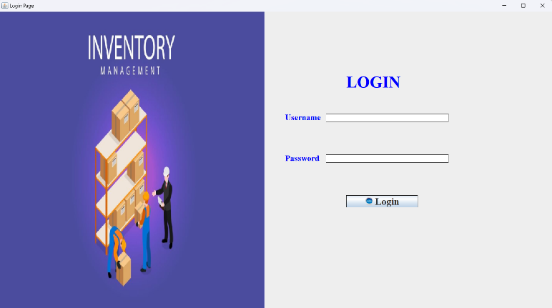

**Img 1: Login Page**

* This page is for a Swing-based GUI application that provides a login interface. It connects to a database, allows users to input a username and password, and checks these credentials against records in the database. If the credentials match, it displays a success message and opens a new window; otherwise, it shows an error message.

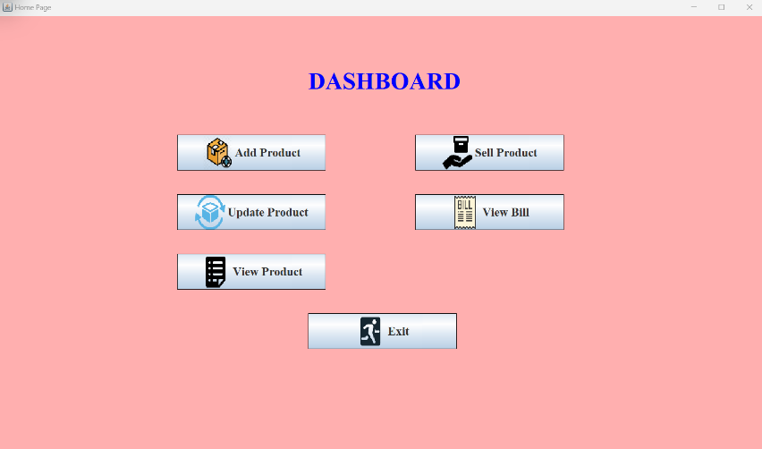

**Img 2: Admin Dashboard**

* Admin dashboard facilitates efficient management of product inventory, enabling updates on stock levels, selling products, and maintaining accurate records. With user-friendly interfaces, administrator can navigate seamlessly to provide optimal Inventory products management.

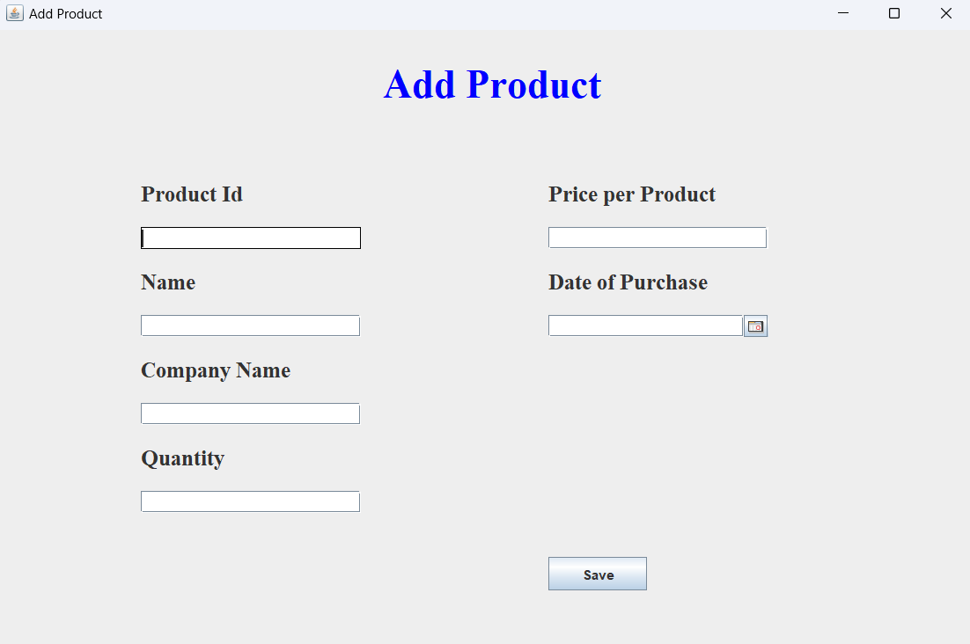

**Img 3: ADD PRODUCT**

* In the admin dashboard, administrators have the capability to add products to his/ her inventory seamlessly. This functionality provides a centralized control for inventory management, allowing administrators to effortlessly include new products, set roles, and manage details effectively. The streamlined process enhances administrative efficiency and ensures a well-organized system within the inventory management application.

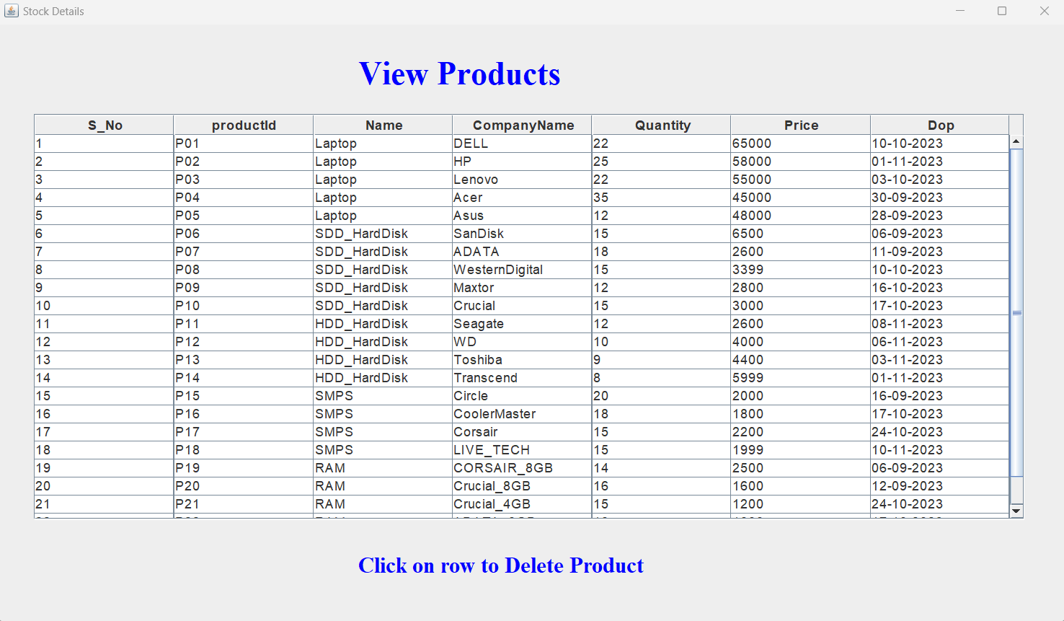

**Img 4: View Products**

* The "View Product" module facilitates streamlined access and management of product information. It presents a structured overview with essential details such as ID, name, company, quantity, price, and purchased date. Administrators can efficiently navigate and delete entries, ensuring a well-organized and up-to-date product inventory. This module significantly contributes to effective inventory control.

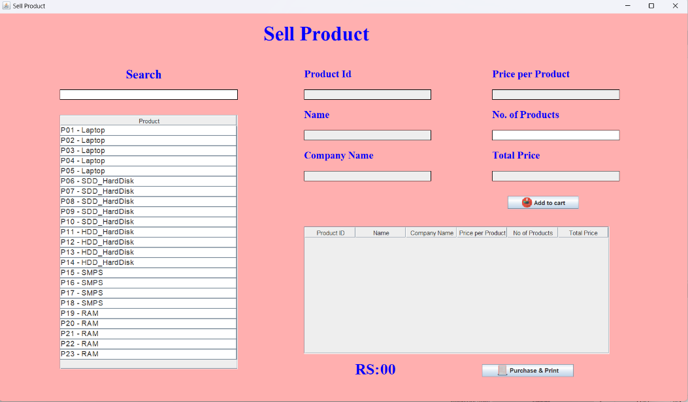

**Img 5: Sell Product**

* The "Sell Product" feature enables pharmacists to effortlessly record and process product sales. With a user-friendly interface, customers can add their products to the cart, and generate accurate bills. The feature ensures efficient tracking of sales transactions, helping maintain accurate sales records and contributing to a seamless inventory management experience.

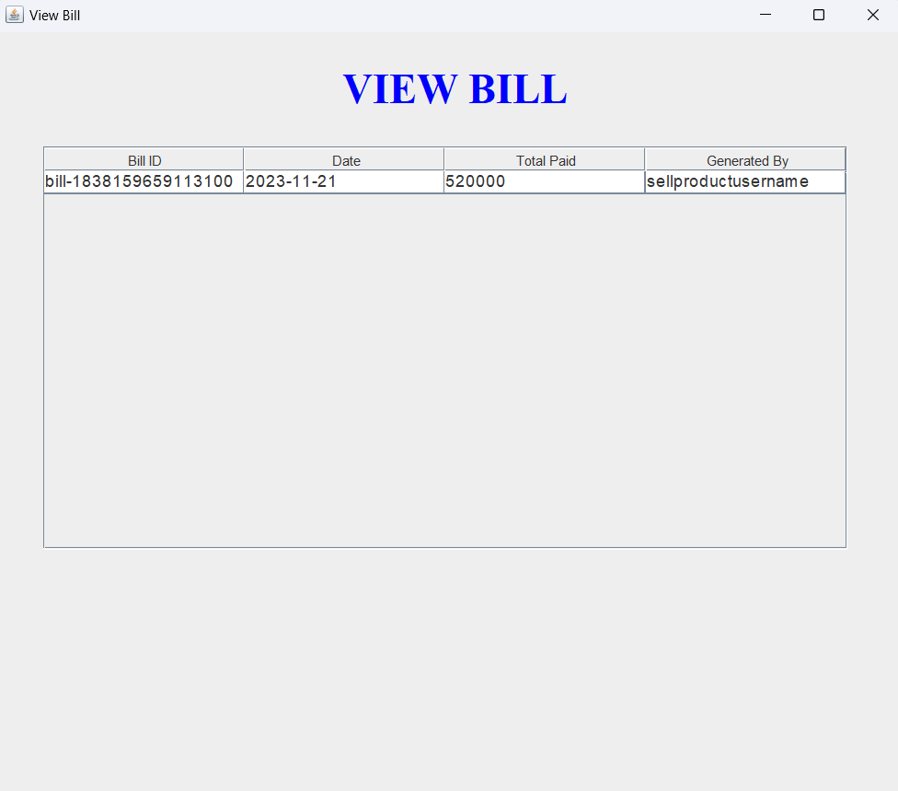

**Img 6: View Bill**

* The "View Bill" feature enables administrators to effortlessly maintain a track of generated bills in the database. The feature ensures efficient tracking of sales transactions, helping maintain accurate sales records and contributing to a seamless inventory management experience.

**12.STUDENT SELF EVALUATION SHEET**

**13. PHOTOS & VIDEO LINKS**

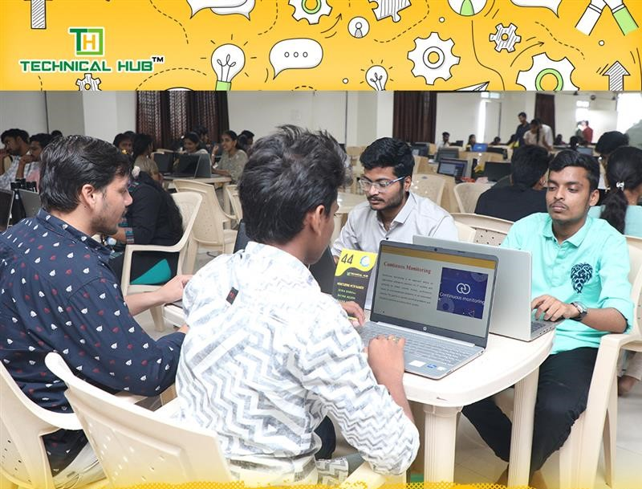

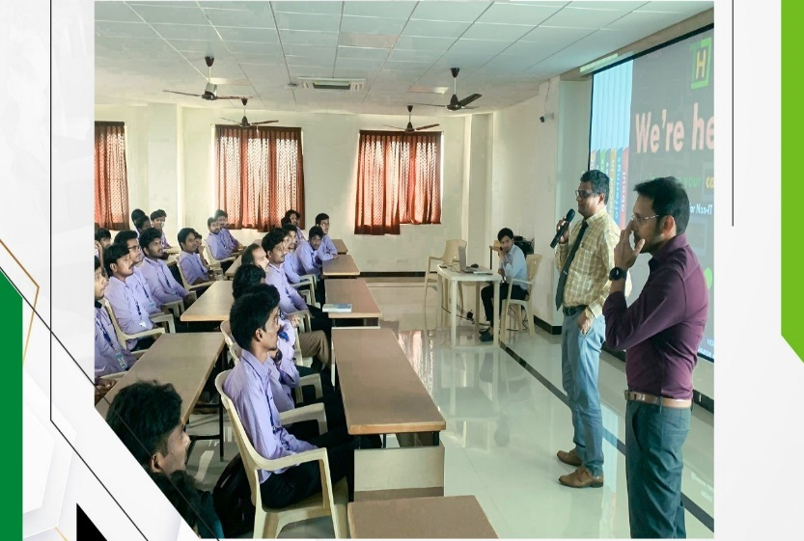

**Hacker Rank Java Link:**

[**https://www.hackerrank.com/domains/java?filters%5Bstatus%5D%5B%5D=unsolved&badge_type=java**](https://www.hackerrank.com/domains/java?filters%5Bstatus%5D%5B%5D=unsolved&badge_type=java)

**JAVA Swing and AWT Tutorial Link:**

[**https://www.javatpoint.com/awt-and-swing-in-java**](https://www.javatpoint.com/awt-and-swing-in-java)

**YouTube JDBC Connectivity Link:**

[**https://www.youtube.com/results?search_query=jdbc+connectivity**](https://www.youtube.com/results?search_query=jdbc+connectivity)

**NPTEL Course Link:**

[**https://onlinecourses.nptel.ac.in/noc22_cs47/preview**](https://onlinecourses.nptel.ac.in/noc22_cs47/preview)